SOYC TRAINING FEEDBACK FORM 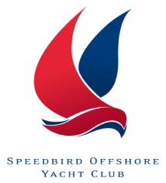
Please complete the details below:

Name

Trainer

Course/Date

For each question, please put an ‘X’ in the appropriate box:

- Course Outcomes | 1  Not at all | 2 | 3 | 4  Definitely
  - Overall, did you find the course was worthwhile?

1.2 Overall, do you feel it will have a positive impact on your sailing ability, helping you to learn new skills and improve on existing ones?

- Course Content | 1  Not at all | 2 | 3 | 4  Definitely
  - Did the course meet your expectations?

2.2 Did you feel that there was a good split between theory and practical teaching?
2.3 Did you feel the course was well structured and easy to follow?

- Timing | 1  Not at all | 2 | 3 | 4  Definitely
  - Did you feel the overall length of the course was
appropriate?

  - Did you feel you would benefit from a longer session?

- Instructor | 1  Not at all | 2 | 3 | 4  Definitely
  - Did you have confidence in your Instructor?

  - Did the Instructor communicate in a clear manner which was easy to understand explaining exercises clearly?

  - Did the Instructor create an environment which was helped you to learn?
  - Did the trainer check understanding throughout the course?

Overall, what worked well for you? Please comment below:

Overall, what did not work well for you; what could be improved? Please comment belo

Ideally, how often would you like to attend a course like this?

Any further comments you would like to make about your course of SOYC Training in general?

Thank you for completing this questionnaire.
Please return it to training@soyc.co.uk

